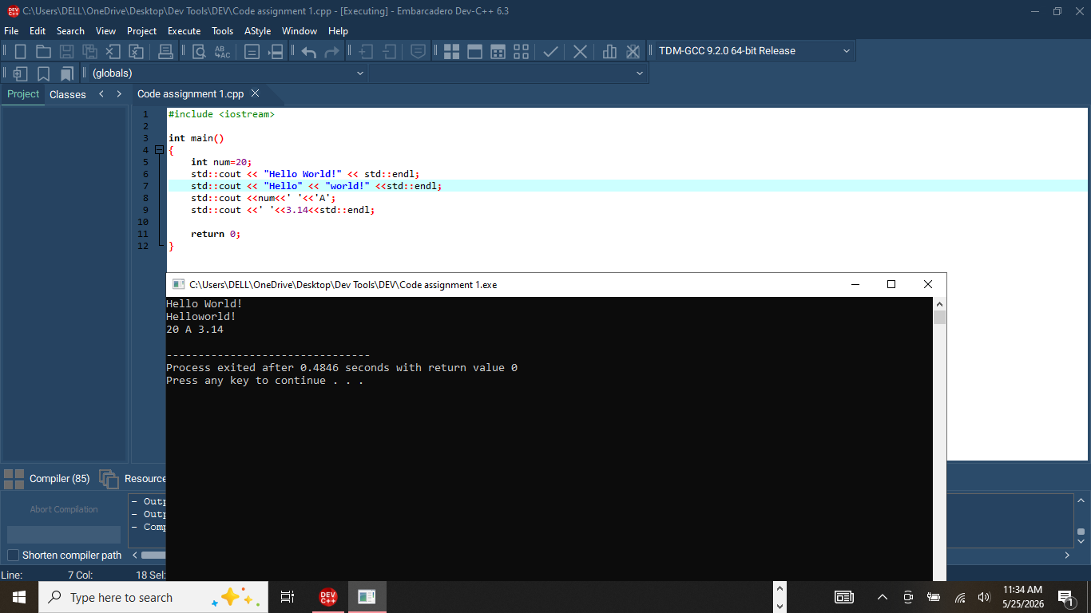
- #include <iostream> allows input and output.
- std::cout displays output on the screen.
- std::endl moves to the next line.

Output
Hello World!

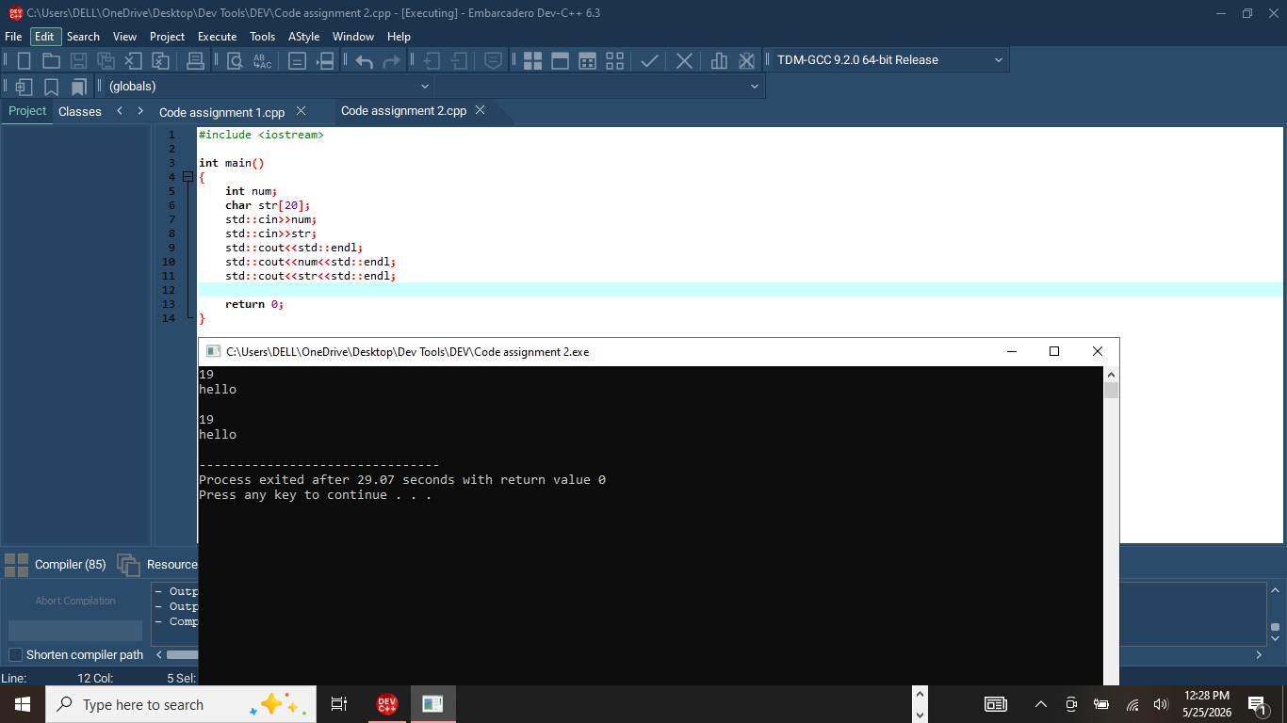
- std::cin takes input from the user.
- >> stores the value entered into the variable.
Example Output
Enter your age: 20
Your age is 20

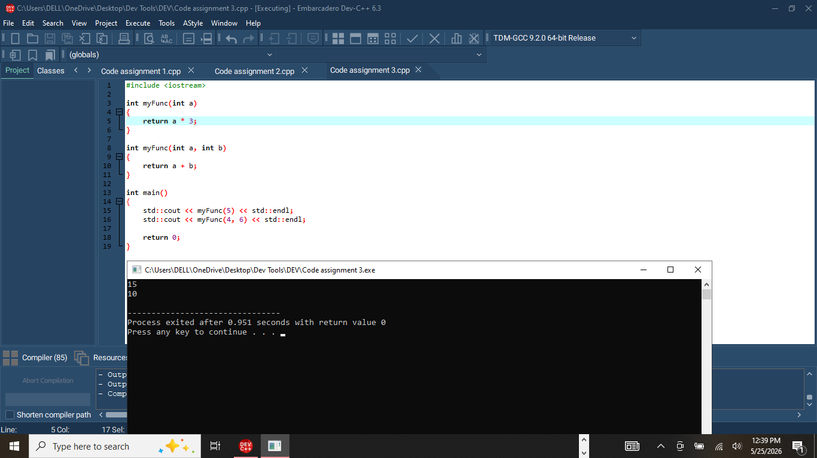

- Two functions have the same name but different parameters.
- C++ distinguishes them using parameter number/type.
Output
15
10

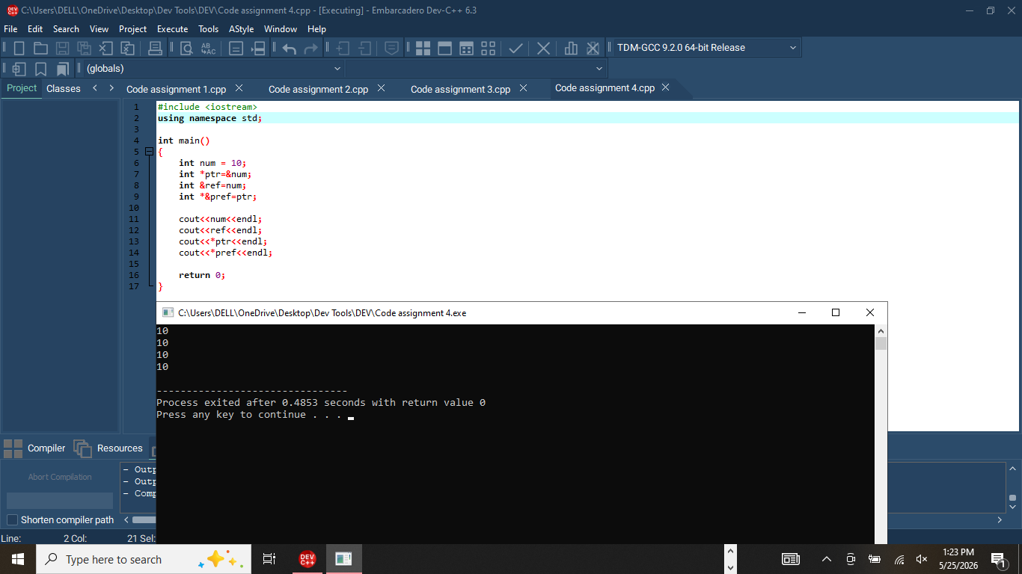

- ref is another name for num.
- Changing ref also changes num.
Output
10
10
10
10

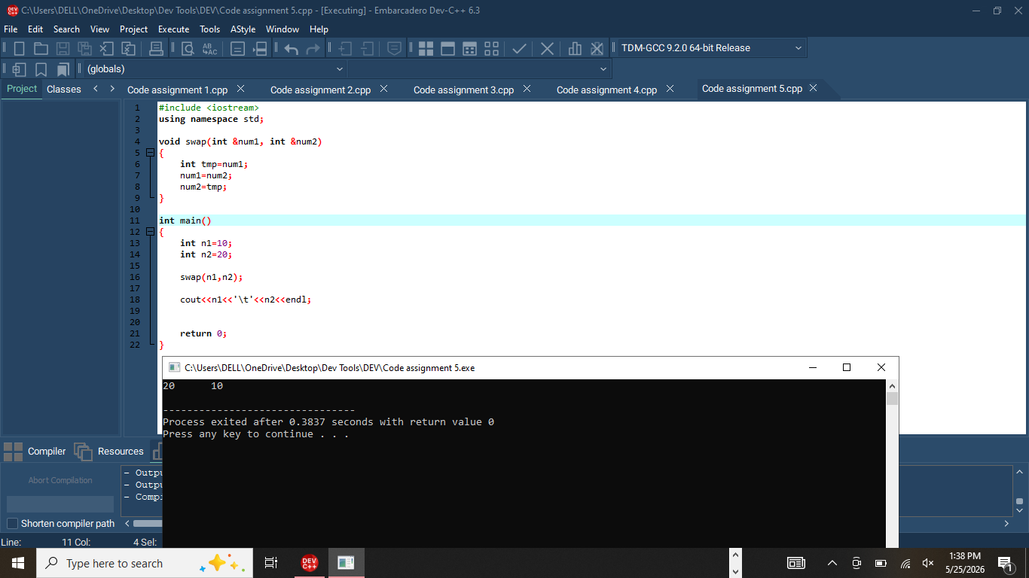
- The reference parameter directly changes the original variable.
Output
20 10

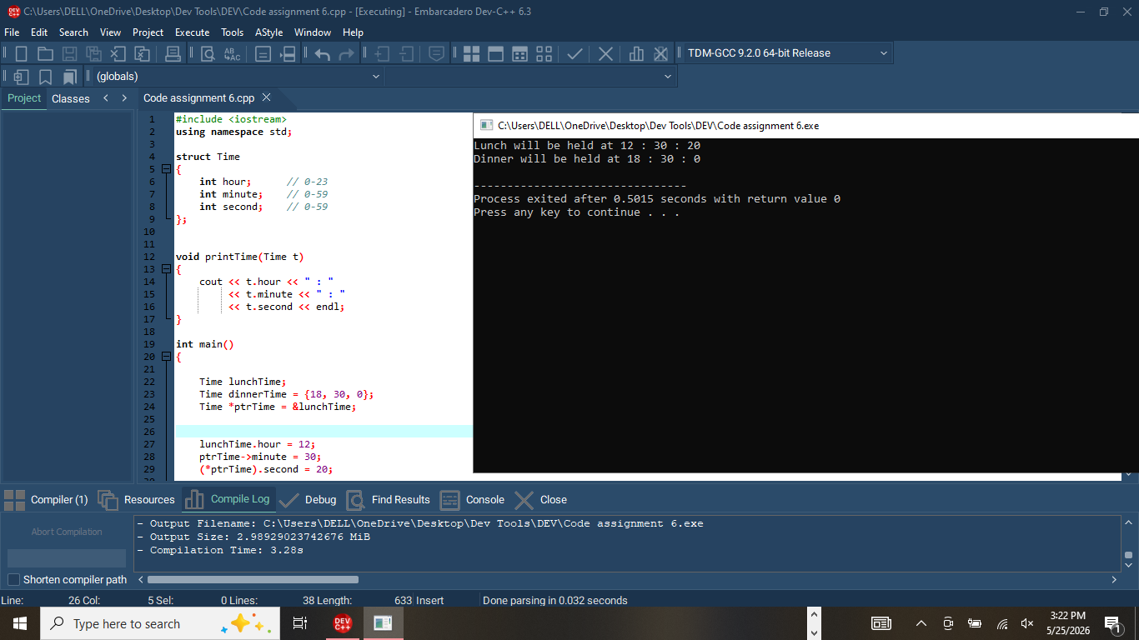

- struct Time groups hour, minute, and second together.
- . accesses members directly.
- -> accesses members through a pointer.
- printTime() displays the time.

Output
Lunch will be held at 12 : 30 : 20
Dinner will be held at 18 : 30 : 0

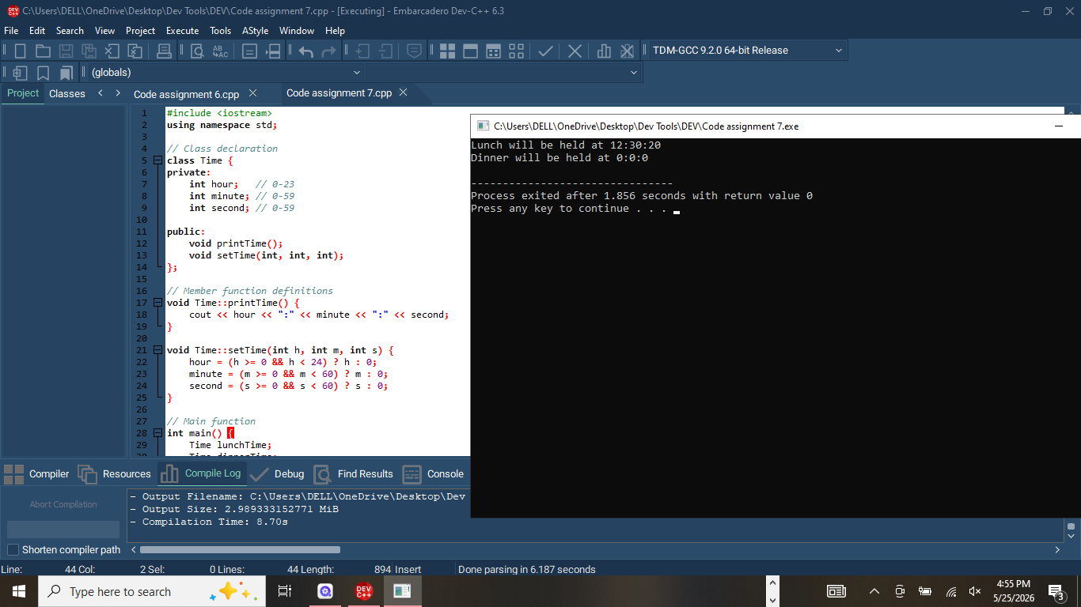
- Has 3 private variables: hour, minute, second
- setTime() - sets the time with validation (checks if values are valid)
- printTime() - displays the time
Main Function:
- Creates 2 Time objects: lunchTime and dinnerTime
- Sets lunchTime to 12:30:20 (valid time)
- Sets dinnerTime to 50:70:80 (invalid time - exceeds limits)

OUTPUT
Lunch will be held at 12:30:20
Dinner will be held at 0:0:0

